**Learning app for Deaf and Mute and sign language English to Gujarati Converter**

***Project Progress Report-II***

*Abstract*

This project explores an AI-driven approach to learning Indian Sign Language (ISL) by developing an interactive mobile application that provides gesture-to-text translation and an offline learning module. The application integrates on-device machine learning (ML) for sign recognition, leveraging TensorFlow Lite (TFLite) or MediaPipe to ensure real-time performance. By combining multiple learning methodologies, the proposed system aims to enhance accessibility for individuals with hearing and speech impairments. The app enables users to learn ISL progressively, from basic alphabets to complex gestures, making communication more inclusive. The project also ensures user engagement through structured lessons, periodic evaluations, and interactive tutorials. Additionally, the system's modular design allows for future scalability, ensuring seamless updates and the integration of new learning features as required.

*Introduction*

The lack of widespread adoption and awareness of Indian Sign Language (ISL) poses communication challenges for the deaf and mute community. Although there are several applications available for American Sign Language (ASL), there is a significant gap when it comes to ISL. The few ISL applications that do exist are often incomplete, outdated, or lack a user-friendly interface. Many of these apps fail to provide an interactive experience, making it difficult for users to effectively learn and practice sign language. Furthermore, there is no well-integrated gesture recognition system tailored specifically for ISL, making the learning process even more challenging.

Existing solutions primarily focus on static images and videos rather than real-time interactive learning, limiting their effectiveness. This project aims to bridge the communication gap by integrating gesture recognition with a structured learning framework for ISL. Additionally, our solution integrates audio-based learning assistance, real-time feedback, and progress tracking to make the learning process more immersive and effective for users of all levels. The project further incorporates intelligent user tracking mechanisms that adapt to individual learning progress, ensuring an optimized educational experience tailored to each user’s needs.

*Motivation*

Why This Research?

Despite numerous technological advancements, there is a lack of comprehensive ISL learning tools that provide an interactive, personalized, and AI-powered experience. The absence of real-time gesture recognition and translation capabilities limits the accessibility and effectiveness of current tools. By addressing these limitations, this research aims to develop a holistic AI-powered educational platform that not only teaches ISL but also enables real-time communication assistance for users. The importance of developing an inclusive and effective communication tool cannot be overstated, particularly in a country with significant linguistic diversity and where the need for accessibility solutions is growing.

Another major concern is that while ASL applications are widely available, ISL remains largely neglected. Many people assume that sign languages are universal, but they are not. ISL has unique signs and grammar distinct from ASL or British Sign Language (BSL). This lack of proper resources for ISL learning further marginalizes the deaf and mute community in India, making communication barriers even harder to overcome. Thus, developing a high-quality ISL learning app is not just a technological advancement but a social necessity.

Problems in Existing Methods:

Limited Real-Time Interaction – Current ISL learning tools rely on static images or videos, offering minimal real-time feedback.

Unimodal Learning – Most platforms focus solely on video-based learning, neglecting interactive elements that engage users.

Lack of Offline Accessibility – Many tools require an internet connection, limiting access in areas with poor connectivity.

No Adaptive Learning Paths – Platforms lack personalized content, failing to adjust to the learner's pace and preferences.

Absence of Multi-Device Synchronization – Users struggle to access their progress across different devices due to a lack of cloud synchronization.

No Standardized ISL Platform – Unlike ASL, which has widely accepted resources, ISL lacks a comprehensive and structured digital learning platform.

*Problem Statement*

Problem Definition:

Limited Accessibility – Existing ISL platforms lack interactivity, real-time feedback, and offline support.

Lack of AI Integration – Gesture recognition models are underutilized in ISL learning, hindering effective learning experiences.

Non-Personalized Learning Paths – The absence of adaptive learning paths reduces effectiveness for learners with different skill levels.

No Integration of Multimodal Features – A holistic approach combining visual, textual, and auditory feedback is missing.

Need for Efficient and Engaging Learning Tools – Structured and interactive tools are needed to make ISL education more effective.

Lack of Continuous Updates and Improvement – Many existing tools lack regular updates, leading to outdated content.

No Standardized Learning Curriculum – ISL lacks a structured curriculum and easily accessible digital learning resources.

*Objectives of the Project*

1. Develop an AI-Powered ISL Learning App – Implement a structured learning platform with gesture-to-text conversion and interactive exercises.
2. Enhance Accessibility Through Offline Mode – Use SQLite for local storage and Firebase Firestore for cloud-based sync.
3. Use AI to Enable Real-Time Feedback – Implement a TFLite or MediaPipe-based gesture recognition model.
4. Provide a Comprehensive ISL Learning Experience – Ensure users can progressively improve their skills through a structured curriculum.
5. Ensure Cross-Platform Compatibility – Enable users to access their progress across multiple devices seamlessly.
6. Bridge the Gap Between ISL and Digital Learning – Create a standardized ISL learning platform, similar to widely available ASL apps.

*Methodology*

System Architecture

The system follows a three-tier architecture:

* Presentation Layer: Android mobile UI (Kotlin/XML) for user interaction.
* Processing Layer: On-device ML model (TFLite/MediaPipe) for gesture detection and translation.
* Data Layer: Uses SQLite for offline storage and Firebase Firestore for cloud sync.

Backend Module (AI Model & Data Processing)

1. Data Collection & Preprocessing:
   * Curated ISL gesture images and videos.
   * Image preprocessing techniques applied (e.g., noise reduction, augmentation).
2. Feature Extraction & Model Development:
   * ML models trained on gesture images for classification and recognition.
   * Fusion of visual and text-based feedback.
3. Training & Evaluation:
   * The system is evaluated using accuracy, precision, and recall metrics.

Frontend Module (User Interface & Experience)

The frontend of the ISL Learning App is designed using Kotlin (for Android) and XML for UI design, focusing on a user-friendly and interactive learning experience. It includes structured learning modules, real-time gesture recognition, and offline accessibility.

1. Home Screen

* Displays categories: Basic Signs, Common Phrases, Advanced Gestures.
* Provides a Live Gesture Capture button to access real-time recognition.

2. Learning Module

* Users select a sign to view gesture illustrations alongside textual translations.
* Camera mode allows users to mimic gestures while receiving instant feedback through the AI recognition model.

3. Live Gesture Recognition Screen

* Opens the camera module for real-time sign recognition.
* The AI model analyzes the user's hand movements and provides instant feedback on accuracy.
* Displays recognized gestures with their English and ISL translations.

*Data Flow Diagrams*

Entity Relationship Diagram

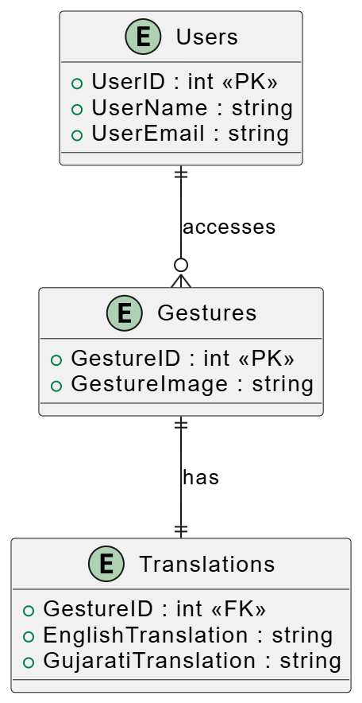

Use Case Diagram

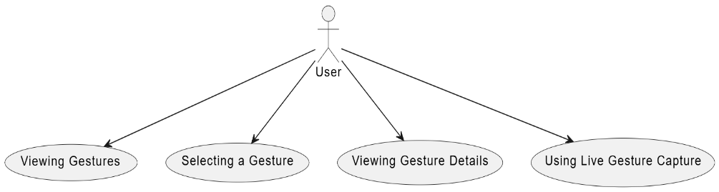

Class Diagram

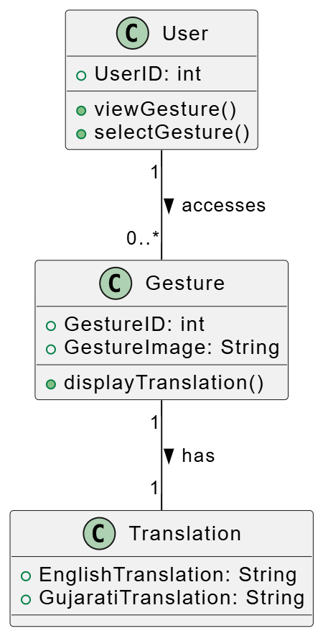

Activity Diagram

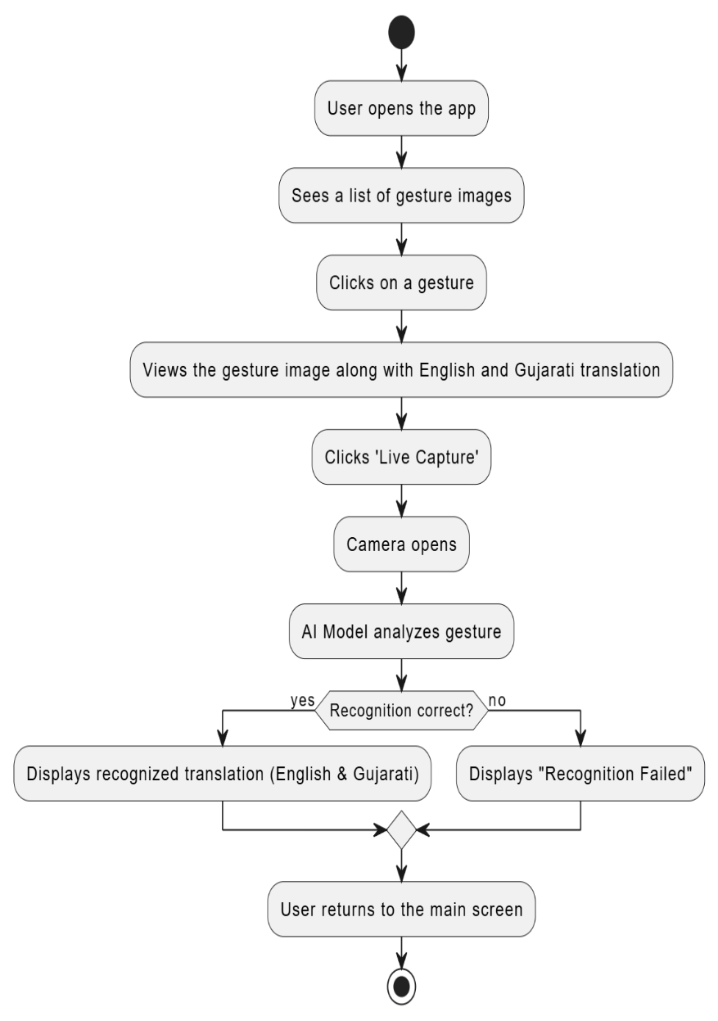

Sequence Diagram

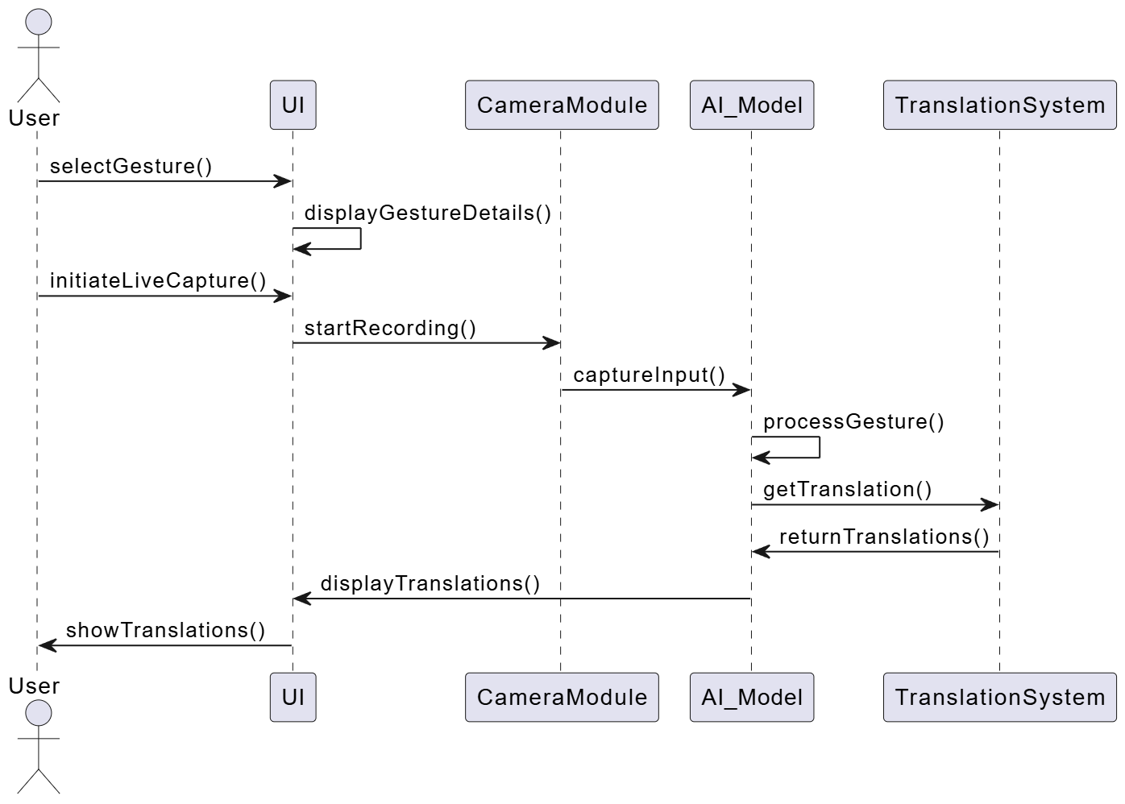

State Diagram

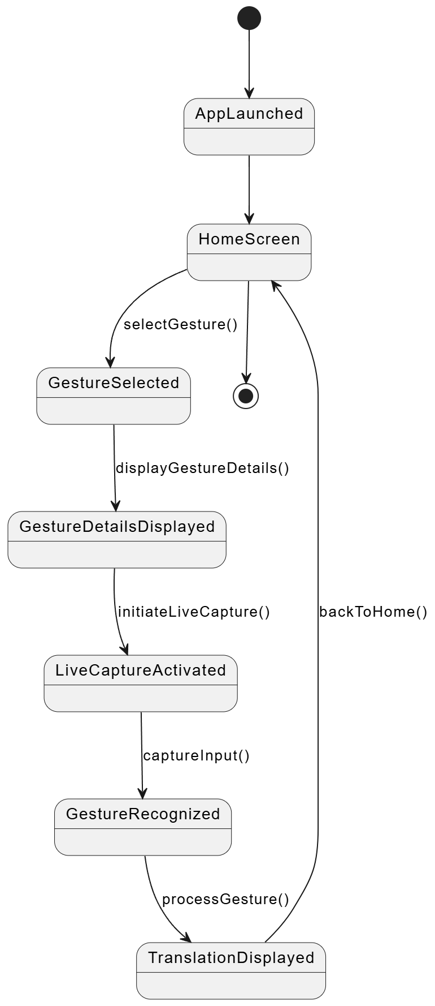

*Planning of Work & Project Timeline*

Gantt Chart for Project Activities

|  |  |  |  |  |  |
| --- | --- | --- | --- | --- | --- |
| Task | Week 1-4 | Week 5-9 | Week 10-13 | Week 14-17 | Week 18-20 |
| Research & Data Collection | ████████ |  |  |  |  |
| Model Training & Optimization |  | ████████ |  |  |  |
| Integration with Mobile App |  |  | ████████ |  |  |
| Testing & Debugging |  |  |  | ████████ |  |
| Deployment & Final Report |  |  |  |  | ████████ |

*Phases of the Project*

The project is divided into the following key phases:

Phase 1: Research & Data Collection (Week 1 - 4)

* Conduct a literature review on Indian Sign Language (ISL) learning and gesture recognition techniques.
* Collect datasets of ISL gestures and corresponding translations.
* Apply image preprocessing techniques (resizing, noise reduction, augmentation) to improve model accuracy.

Phase 2: Model Development (Week 5 - 9)

* Develop CNN-based gesture recognition models using TensorFlow Lite (TFLite) or MediaPipe.
* Train the model using gesture datasets and evaluate its classification accuracy.
* Fine-tune the model to optimize gesture recognition performance.

Phase 3: System Integration & Optimization (Week 10 - 13)

* Integrate the trained AI model into the Android application for real-time recognition.
* Implement gesture-to-text translation and structured learning modules.
* Optimize real-time processing efficiency to ensure smooth user experience.

Phase 4: Testing & Debugging (Week 14 - 17)

* Conduct unit testing, functional testing, and user acceptance testing on the application.
* Compare the AI model's performance against expected results.
* Fix bugs, enhance UI/UX, and improve overall app responsiveness.

Phase 5: Deployment & Documentation (Week 18 - 20)

* Deploy the final version of the ISL learning application.
* Prepare detailed project documentation including reports, system architecture, final presentation and usage guidelines.

*Conclusion*

Summary of Findings:

* ISL remains underrepresented in the digital learning space.
* AI-powered gesture recognition significantly enhances ISL learning.
* Integration of structured learning modules increases user engagement.
* Offline accessibility ensures usability in low-connectivity areas.

*Final Thoughts*

This project provides a comprehensive AI-powered solution for ISL learning that combines real-time gesture recognition, interactive learning modules, and structured lessons. Future enhancements will focus on scalability, accuracy improvements, and multilingual support to make the application more inclusive and widely adopted. The development of this ISL learning platform is not just a technological innovation but a step toward greater social inclusivity and accessibility for the deaf and mute community.

**Project Supervisor** : Mrs B Sonal  
**Team** : Abhinay Srikanth K 1608-21-733-149

Md. Abdul Rahman 1608-21-733-319  
 B. Kiran Kumar 1608-21-733-192